SonarQube Static Analysis Report
Date of Analysis: 18.03.2026
Results Overview
Metric | Value
Quality Gate | Passed
Security | 0
Reliability | 0
Security Hotspots | 0
Maintainability | 91
Total Issues | ​91
Coverage | 80.0%
Duplications | 0.9%
Accepted Issues | 0

Issues Breakdown by Severity
Severity | Count
Blocker | 1
High | 9
Medium | 47
Low | 32
Info | 2

Key Issues Found

- Add at least one assertion to this test case.
- Define a constant instead of duplicating this literal "MIL-M001" 5 times.
- Define a constant instead of duplicating this literal "ROM-ES002" 4 times.

Screenshots


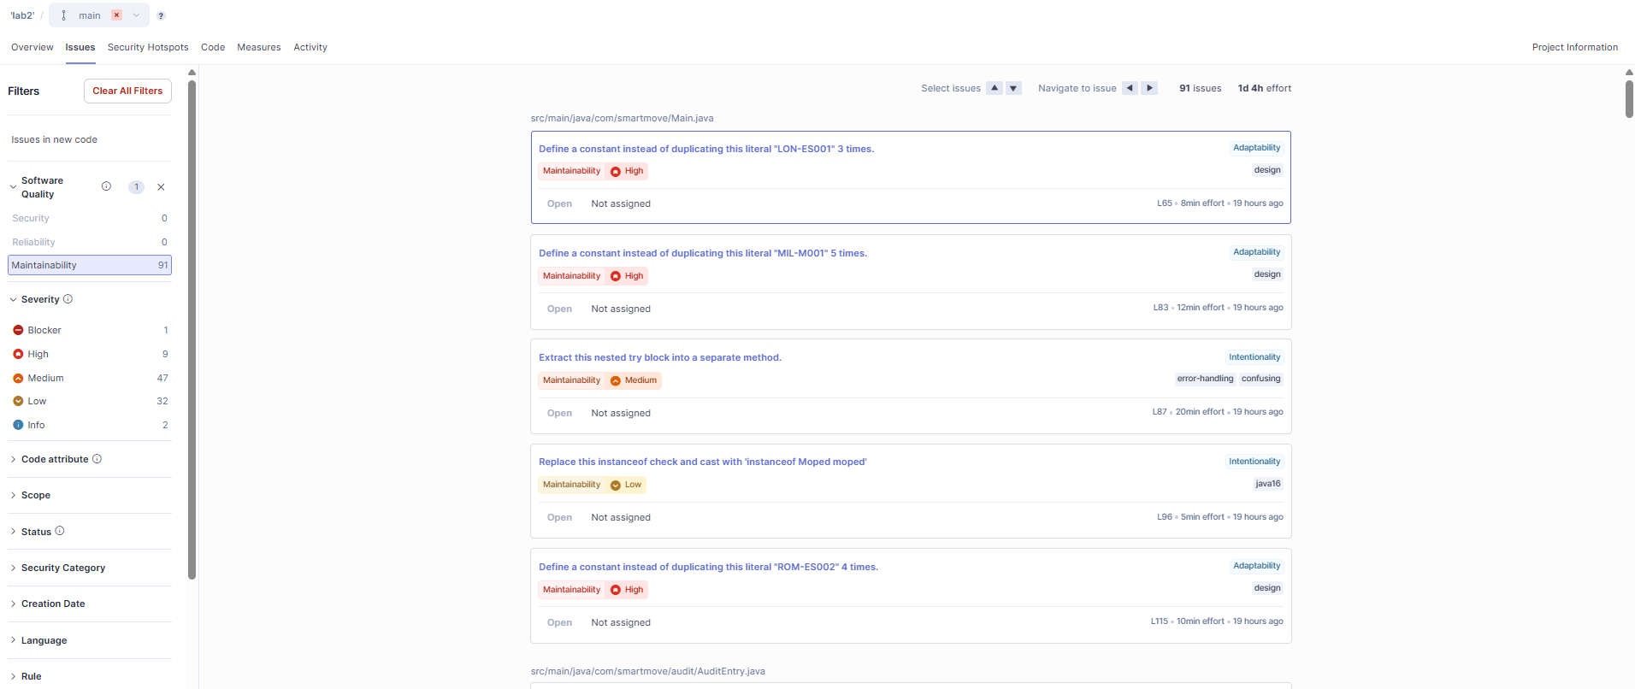

Analysis Conclusion
The static analysis of the SmartMove Core Engine revealed a total of 91 issues. All of issues are Maintainability. The analysis confirms that the codebase implements the required functionality but would benefit from refactoring in areas of complexity.

